MARCH BREAKFAST PROGRAM

Every morning we come together to break bread!!!
The program is offered to everyone at no cost.
Breakfast will be served everyday from 8:30 am-8:45 am.
Please ensure that your child arrives at school at 8:30 am to benefit from the breakfast program.

SUNDAY | MONDAY | TUESDAY | WEDNESDAY | THURSDAY | FRIDAY | SATURDAY

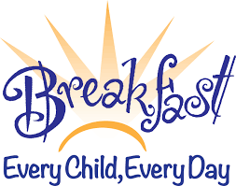 |  |  |  | 1  Scrambled Eggs  Fruit | 2  Yogurt  Parfait | 3
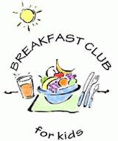 | 5  Hot Oatmeal  Or Cereal  Fruit | 6  Smoothie  Muffins | 7  Fruit  Toast  Milk | 8  Egg Wraps  Fruit  Milk | 9  Cheese  Triscuits  Fruit | 10
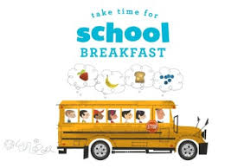 | 19  Hot Oatmeal  Or Cereal  Fruit | 20  Grilled Cheese  Fruit  Milk | 21  Yogurt Tubes  Toast | 22  Scrambled Eggs  Fruit  Milk | 23  Yogurt  Parfait | 24
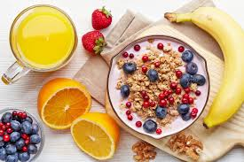 | 26  Hot Oatmeal  Or Cereal  Fruit | 27  Egg Wraps  Fruit  Milk | 28  Fruit  Toast  Milk | 29  Smoothie  Muffins | 30  Good Friday  NO School | 31

