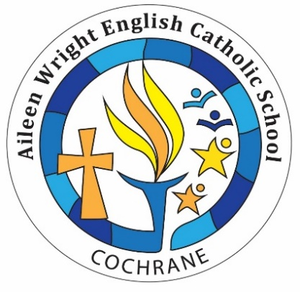
April Newsletter
MONTHLY VIRTUE
Our Monthly Virtue for April continues to be Courage.
“Courage is the most important of all the virtues because without courage, you can't practice any other virtue consistently.”
― Maya Angelou
INSTRUCTIONAL FOCUS
In Language Arts, we are focusing on Persuasive Writing. In Mathematics, we are focusing on Data Management and Probability moving into Number Sense and Numeration. They are becoming critical thinkers!

PA DAY
A friendly reminder that Monday, April 8 is a Professional Activity Day. Enjoy your long weekend with your children!
EASTER WEEKEND
Just a friendly reminder that Friday, April 19 is Good Friday and Monday, April 22 is Easter Monday. Another long weekend with your children!
NEXT FUNDRAISER
With our Grade 7 & 8 Educational Trip quickly approaching, we are exploring our next Fund-Raising initiatives. More exciting information to come….

CATHOLIC SCHOOL COUNCIL
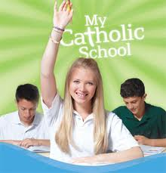
Our April Catholic School Council Meeting is scheduled for Thursday, April 25 at 7:00pm. Hope to see you there!
A huge “THANK YOU” to all students for your ongoing fund-raising efforts.
PIZZA DAY
Please send $2.00 for a slice of Pizza on Thursday, April 25 as Friday, April 26 is Pizza Day this month. We are also selling popcorn for $2.00 a bag every Friday.
We are excited to share that we will be having some hot dog days to raise monies for our upcoming Grade 7 & 8 Educational Trip.

SCHOOL UNIFORMS
Just a friendly reminder, it is mandatory for your child to arrive at school wearing proper school uniform. The proper school uniform consists of a school uniform top and black bottom. Every Friday is dress down day!

STUDENT SUCCESS REMINDERS
Studies have shown that student achievement is based on regular attendance. It is so important that your child attend school on a daily basis.
It is also important to note that the bell to start important morning activities rings at 8:45 am. Student supervision is from
8:30 am- 8:45 am.

As always, please don’t hesitate to contact the school if you have any questions and/or concerns. Your continued support and understanding are greatly appreciated! Thank you for sharing your children with us!
Yours in Catholic Education,
Andrea Iserhoff
Principal

